BANK LOAN
ANALYSIS
Data Analytics Project Report

Prepared By
_________ABHISHEK ANTHONY ________

Tools Used
Excel | Python | SQL | Power BI |Ai Tool

Project Type
End-to-End Data Analytics Project

Version 1.0
July 2026
Table of Contents

- Chapter | .
- Cover Page
- Table of Contents
- Executive Summary
- Problem Statement
- Project Objectives
- Dataset Overview
- Tools & Technologies Used
- Data Cleaning & Preprocessing
- Exploratory Data Analysis (EDA)
- SQL Analysis
- Power BI Dashboard
- Executive Overview Dashboard
- Loan Performance Dashboard
- Customer Analysis Dashboard
- Geographic Analysis Dashboard
- Key Business Insights
- Business Recommendations
- Conclusion
- Future Scope

Executive Summary

- Introduction
- The Bank Loan Analysis Dashboard is an end-to-end data analytics project developed to analyze loan application data and provide meaningful business insights through interactive dashboards. The project demonstrates the complete data analytics workflow, starting from data cleaning and preprocessing, followed by SQL-based analysis, and ending with the development of an interactive Power BI dashboard.
- The primary objective of this project is to help financial institutions understand customer borrowing behavior, evaluate loan performance, identify potential risks, and support data-driven decision-making. By transforming raw loan data into meaningful visualizations, the dashboard enables decision-makers to monitor key performance indicators and identify important business trends.
- The project follows a structured analytics approach, including data preparation, exploratory data analysis (EDA), SQL querying, data modeling, DAX measure creation, and dashboard development. Each stage contributes to improving data quality and generating actionable business insights.
- The dashboard consists of four interactive pages: Executive Overview, Loan Performance Analysis, Customer Analysis, and Geographic Analysis. Together, these dashboards provide a comprehensive view of loan applications, funded amounts, repayment performance, customer characteristics, and state-wise loan distribution.
- This project was developed using Python, Pandas, NumPy, MySQL, SQL, Microsoft Power BI, and DAX. These technologies were used to clean the dataset, perform business analysis, calculate key performance indicators, and build interactive visualizations for business users.
- Overall, the project demonstrates practical data analytics skills and highlights how business intelligence tools can support better financial decision-making through data visualization and reporting.

- Key Highlights
- Developed an end-to-end Banking Loan Analysis project using real-world style loan data.
- Cleaned and transformed raw data using Python and Pandas.
- Performed Exploratory Data Analysis (EDA) to identify trends and data quality issues.
- Stored the cleaned dataset in MySQL for structured analysis.
- Wrote SQL queries to answer important business questions and calculate KPIs.
- Designed interactive dashboards in Power BI using DAX measures.
- Built four dashboard pages covering Executive Overview, Loan Performance, Customer Analysis, and Geographic Analysis.
- Generated business insights and recommendations to support strategic decision-making.

Problem Statement

- The banking industry processes thousands of loan applications every day. Each application contains valuable information about customers, loan amounts, repayment history, loan purpose, interest rates, and loan status. As the volume of data increases, it becomes difficult for decision-makers to manually analyze this information and identify meaningful patterns.
- Without an effective data analysis system, banks may face challenges in monitoring loan performance, identifying high-risk customers, understanding customer borrowing behavior, and making informed lending decisions. Traditional reporting methods are often static and time-consuming, making it difficult to gain real-time business insights.
- To overcome these challenges, financial institutions require an interactive Business Intelligence solution that transforms raw loan data into meaningful dashboards and reports. Such a solution enables stakeholders to monitor key performance indicators (KPIs), analyze customer trends, evaluate loan performance, and identify potential business opportunities.

- 2.2 Business Problem
- The bank needs an interactive analytical solution that answers important business questions, such as:
- How many loan applications have been received?
- What is the total funded loan amount?
- How much payment has been received from borrowers?
- Which loan grades perform the best?
- Which loan purposes are most common among customers?
- Which customer segments contribute the highest number of loan applications?
- Which states receive the highest loan funding?
- What percentage of loans are Fully Paid, Current, or Charged Off?
- Which geographical regions require more business attention?
- Answering these questions manually is time-consuming and inefficient. Therefore, an automated dashboard is required to provide accurate insights and support faster business decisions.

- 2.3 Proposed Solution
- To address the above challenges, an end-to-end Banking Loan Analysis Dashboard was developed using Python, SQL, MySQL, and Microsoft Power BI.
- The solution follows a structured data analytics workflow:
- Raw loan data was cleaned and preprocessed using Python.
- Exploratory Data Analysis (EDA) was performed to understand the dataset and identify trends.
- The cleaned data was stored in MySQL for structured querying.
- SQL was used to calculate key business metrics and answer analytical questions.
- Power BI was used to build interactive dashboards with dynamic filters, KPIs, charts, and maps.
- DAX measures were created to calculate business metrics such as Total Loan Applications, Total Funded Amount, Total Payment Received, Average Interest Rate, and Average Annual Income.
- The final dashboard enables business users to analyze loan performance, customer behavior, repayment trends, and geographic distribution through interactive visualizations, helping management make informed, data-driven decisions.

- 📌 Key Business Questions
- Add this as a separate text box or subsection:
- The project aims to answer the following key business questions:
- What is the total number of loan applications received?
- What is the total funded loan amount?
- How much payment has been received from borrowers?
- Which loan grades receive the highest funding?
- Which loan purposes are most common?
- Which customer segments apply for the most loans?
- Which states contribute the highest loan volume?
- What is the distribution of loan status (Fully Paid, Current, Charged Off)?
- What insights can help improve business performance and reduce lending risk?

- Raw Dataset
- ↓
- Data Cleaning (Python)
- ↓
- EDA
- ↓
- MySQL Database
- ↓
- SQL Analysis
- ↓
- Power BI Dashboard
- ↓
Business Insights

Objectives
- Project Goal
- The primary goal of this project is to develop an interactive Bank Loan Analysis Dashboard that enables financial institutions to monitor loan performance, analyze customer behavior, evaluate repayment trends, and support strategic decision-making through data-driven insights.
- This project demonstrates the complete data analytics lifecycle, beginning with data cleaning and preprocessing, followed by exploratory data analysis, SQL-based business analysis, and finally the development of an interactive Power BI dashboard. The objective is to convert raw banking data into meaningful visualizations that help stakeholders understand business performance efficiently.

- 3.2 Specific Objectives
- The project was designed to achieve the following objectives:
- Data Preparation
- Collect and understand the banking loan dataset.
- Clean the dataset by handling missing values, duplicate records, and inconsistent data.
- Prepare the dataset for further analysis using Python.

- Exploratory Data Analysis (EDA)
- Explore customer and loan-related information.
- Identify trends, distributions, and patterns within the dataset.
- Detect outliers and validate data quality before analysis.

- SQL-Based Business Analysis
- Store the cleaned dataset in MySQL.
- Write SQL queries to answer important business questions.
- Calculate key business metrics using aggregate functions, joins, Common Table Expressions (CTEs), and window functions.

- Dashboard Development
- Design an interactive Power BI dashboard.
- Create meaningful visualizations to represent business performance.
- Develop DAX measures for Key Performance Indicators (KPIs).
- Enable interactive filtering and page navigation for better user experience.

- Business Intelligence
- The dashboard aims to provide insights into:
- Total Loan Applications
- Total Funded Amount
- Total Payment Received
- Loan Status Distribution
- Loan Grade Performance
- Customer Home Ownership Analysis
- Occupation-wise Loan Analysis
- State-wise Loan Distribution
- Geographic Performance
- Loan Term Analysis
- Average Interest Rate
- Average Annual Income

- Business Decision Support
- The final objective of this project is to support business users in making informed decisions by:
- Identifying high-performing loan categories.
- Understanding customer borrowing behavior.
- Monitoring repayment performance.
- Evaluating regional loan distribution.
- Supporting strategic planning using data visualization.

Dataset Overview

- Project Goal
- The primary goal of this project is to develop an interactive Bank Loan Analysis Dashboard that enables financial institutions to monitor loan performance, analyze customer behavior, evaluate repayment trends, and support strategic decision-making through data-driven insights.
- This project demonstrates the complete data analytics lifecycle, beginning with data cleaning and preprocessing, followed by exploratory data analysis, SQL-based business analysis, and finally the development of an interactive Power BI dashboard. The objective is to convert raw banking data into meaningful visualizations that help stakeholders understand business performance efficiently.

- 3.2 Specific Objectives
- The project was designed to achieve the following objectives:
- Data Preparation
- Collect and understand the banking loan dataset.
- Clean the dataset by handling missing values, duplicate records, and inconsistent data.
- Prepare the dataset for further analysis using Python.

- Exploratory Data Analysis (EDA)
- Explore customer and loan-related information.
- Identify trends, distributions, and patterns within the dataset.
- Detect outliers and validate data quality before analysis.

- SQL-Based Business Analysis
- Store the cleaned dataset in MySQL.
- Write SQL queries to answer important business questions.
- Calculate key business metrics using aggregate functions, joins, Common Table Expressions (CTEs), and window functions.

- Dashboard Development
- Design an interactive Power BI dashboard.
- Create meaningful visualizations to represent business performance.
- Develop DAX measures for Key Performance Indicators (KPIs).
- Enable interactive filtering and page navigation for better user experience.

- Business Intelligence
- The dashboard aims to provide insights into:
- Total Loan Applications
- Total Funded Amount
- Total Payment Received
- Loan Status Distribution
- Loan Grade Performance
- Customer Home Ownership Analysis
- Occupation-wise Loan Analysis
- State-wise Loan Distribution
- Geographic Performance
- Loan Term Analysis
- Average Interest Rate
- Average Annual Income

- Business Decision Support
- The final objective of this project is to support business users in making informed decisions by:
- Identifying high-performing loan categories.
- Understanding customer borrowing behavior.
- Monitoring repayment performance.
- Evaluating regional loan distribution.
- Supporting strategic planning using data visualization.
This dataset was selected because it closely represents real-world banking operations and provides sufficient information to perform end-to-end data analytics. It contains financial, customer, and geographical attributes that enable meaningful business analysis and interactive dashboard development.
The variety of variables available in the dataset makes it suitable for analyzing loan performance, customer behavior, repayment patterns, and regional business trends while demonstrating practical skills in Python, SQL, MySQL, and Power BI

Tools & Technologies
- This project was developed using a combination of data analytics, database management, and business intelligence tools. Each tool played a specific role in the project, from data cleaning and analysis to visualization and reporting.
- The integration of these technologies enabled the development of a complete end-to-end data analytics solution, transforming raw banking data into meaningful business insights.

- 5.2 Tools Used in the Project
- Tool / Technology | - Purpose in the Project
- Microsoft Excel | - Initial review and understanding of the dataset
- Python | - Data cleaning, preprocessing, and exploratory data analysis (EDA)
- Pandas | - Data manipulation and transformation
- NumPy | - Numerical operations and handling missing values
- MySQL | - Storage and management of the cleaned dataset
- SQL | - Business analysis and KPI calculation
- Power BI | - Interactive dashboard development
- DAX | - Creation of calculated measures and KPIs
- Microsoft Word | - Project documentation and report preparation
- Gama AI | - Professional presentation creation

- 5.3 Role of Each Technology
- Microsoft Excel
- Excel was used to perform an initial review of the dataset, inspect column names, understand the data structure, and verify the dataset before starting the data cleaning process.

- Python (Pandas & NumPy)
- Python was used for data cleaning and preprocessing. The dataset was analyzed to identify missing values, duplicate records, incorrect data types, and outliers. Pandas was used for data manipulation, while NumPy supported numerical computations.

- MySQL
- After cleaning the dataset, it was imported into MySQL. The database provided a structured environment for storing the data and executing SQL queries to answer business questions efficiently.

- SQL
- SQL was used to perform business analysis by calculating KPIs, summarizing loan information, analyzing customer behavior, and evaluating loan performance using aggregate functions, filtering, grouping, Common Table Expressions (CTEs), and window functions.

- Microsoft Power BI
- Power BI was used to build interactive dashboards that present business insights through KPI cards, charts, maps, slicers, and navigation buttons. Relationships and DAX measures were created to support dynamic analysis.

- DAX (Data Analysis Expressions)
- DAX was used to create custom measures such as Total Loan Applications, Total Funded Amount, Total Payment Received, Average Interest Rate, and Average Annual Income. These measures enabled dynamic calculations based on user selections.

- Microsoft Word
- Microsoft Word was used to prepare a structured project report documenting the objectives, methodology, analysis, dashboards, business insights, and recommendations.

- Gama AI
- Gama AI will be used to convert the completed project report into a professional presentation, making it easier to showcase the project during interviews and on professional platforms.

Data Cleaning
- Data cleaning and preprocessing are essential steps in any data analytics project. Raw datasets often contain missing values, duplicate records, inconsistent formats, and data quality issues that can affect the accuracy of analysis and reporting.
- In this project, Python was used to clean and prepare the banking loan dataset before loading it into the MySQL database. A systematic preprocessing workflow was followed to improve data quality and ensure reliable business insights.
- The cleaned dataset served as the foundation for SQL analysis and Power BI dashboard development.

- 6.2 Data Cleaning Process
- The following steps were performed during data preprocessing:
- Step 1: Importing Required Libraries
- The required Python libraries were imported to perform data cleaning and analysis.
- Libraries used:
- Pandas
- NumPy
- Matplotlib
- Seaborn (for exploratory analysis)
- These libraries helped in reading the dataset, manipulating data, identifying missing values, and preparing the dataset for further analysis.

- Step 2: Loading the Dataset
- The banking loan dataset was imported into Python using the Pandas library.
- During this stage, the dataset structure, column names, and data types were verified to ensure successful loading.

- Step 3: Understanding the Dataset
- The dataset was explored using functions such as:
- head()
- info()
- describe()
- shape
- columns
- These functions helped in understanding:
- Number of rows and columns
- Data types
- Summary statistics
- Available variables

- Step 4: Missing Value Analysis
- The dataset was checked for missing values.
- Missing data was identified using Python and handled appropriately to improve data quality.
- Handling missing values ensured that later SQL analysis and Power BI visualizations produced accurate results.

- Step 5: Duplicate Record Check
- The dataset was examined for duplicate records.
- Duplicate entries were identified and removed wherever necessary to avoid incorrect calculations and repeated information.
- This improved the overall consistency of the dataset.

- Step 6: Data Type Validation
- Each column was checked to ensure that it had the correct data type.
- Examples include:
- Dates stored as Date format
- Loan Amount stored as Numeric
- Interest Rate stored as Decimal
- Annual Income stored as Numeric
- Correct data types were necessary for calculations, filtering, and visualization.

- Step 7: Outlier Analysis
- Outlier analysis was performed on numerical columns to identify unusually high or low values.
- The purpose of this step was to understand the data distribution and determine whether extreme values represented genuine business cases or data quality issues.
- The analysis helped improve confidence in the dataset before visualization.

- Step 8: Final Cleaned Dataset
- After completing all preprocessing steps, the cleaned dataset was exported and used for SQL analysis and Power BI dashboard development.
- The final dataset was accurate, consistent, and suitable for business intelligence reporting.

- Raw Banking Loan Dataset
- │
- ▼
- Import into Python
- │
- ▼
- Understand Dataset Structure
- │
- ▼
- Missing Value Analysis
- │
- ▼
- Duplicate Record Check
- │
- ▼
- Data Type Validation
- │
- ▼
- Outlier Analysis
- │
- ▼
- Final Cleaned Dataset
- │
- ▼
Load into MySQL
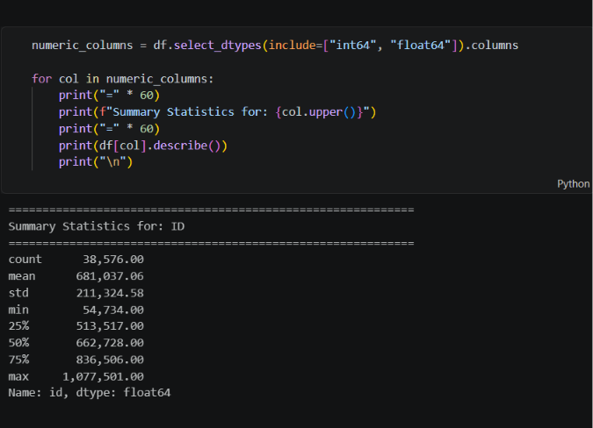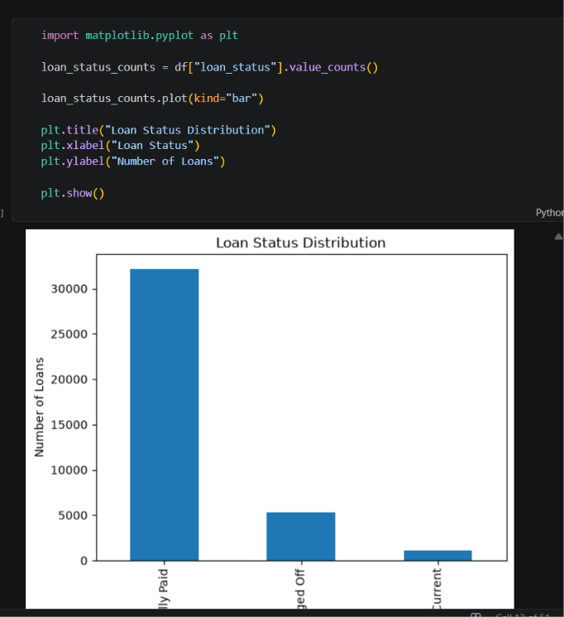

SQL Analysis
- Structured Query Language (SQL) was used to analyze the cleaned banking loan dataset stored in the MySQL database. SQL enabled efficient retrieval, aggregation, filtering, and analysis of the data to answer important business questions.
- The SQL analysis focused on identifying key performance indicators (KPIs), understanding customer behavior, evaluating loan performance, analyzing lending risk, and generating actionable business insights. Different SQL concepts such as aggregate functions, filtering, grouping, Common Table Expressions (CTEs), and window functions were used to perform the analysis.
- The results obtained through SQL formed the foundation for the Power BI dashboards and supported data-driven business decision-making.

- The SQL analysis was divided into five major sections.
- 1. Basic Data Exploration
- The first stage focused on understanding the dataset by analyzing:
- Total number of loan records
- Available columns
- Loan status distribution
- Loan grades
- Customer home ownership
- Loan purposes
- State-wise distribution
- This helped verify the dataset and understand its overall structure before performing advanced analysis.

- 2. Business KPI Analysis
- Business KPIs were calculated to measure the overall performance of the bank.
- The following KPIs were analyzed:
- Total Loan Applications
- Total Funded Amount
- Total Payment Received
- Average Interest Rate
- Average Annual Income
- Average Debt-to-Income Ratio (DTI)
- These KPIs provide a quick overview of the bank's lending performance.

- 3. Customer Analysis
- Customer-focused SQL queries were written to understand customer behavior.
- The analysis included:
- Loan applications by home ownership
- Loan applications by purpose
- Annual income analysis
- Loan grade distribution
- State-wise customer analysis
- Loan term analysis
- This helped identify customer segments and borrowing patterns.

- 4. Risk Analysis
- Risk analysis was performed to evaluate the quality of the loan portfolio.
- The following factors were analyzed:
- Fully Paid loans
- Current loans
- Charged Off loans
- Interest rate trends
- Loan grade performance
- Debt-to-Income Ratio (DTI)
- These analyses help identify potential lending risks and improve credit decision-making.

- 5. Advanced SQL Analysis
- Advanced SQL techniques were used to perform deeper business analysis.
- The project included:
- Aggregate Functions
- CASE Statements
- Common Table Expressions (CTEs)
- Window Functions
- Ranking Functions
- DENSE_RANK()
- Business-focused SQL queries
- These techniques improved query efficiency and enabled more advanced reporting.

- 8.4 Business Questions Solved Using SQL
- The following business questions were answered through SQL:
- How many loan applications have been received?
- What is the total funded loan amount?
- How much payment has been received?
- Which loan grades receive the highest funding?
- Which loan purposes are most common?
- Which states have the highest number of loan applications?
- Which customer segments contribute the most loans?
- Which loan statuses dominate the portfolio?
- Which loans have the highest interest rates?
- Which customer groups present higher lending risk?

Benefits of SQL Analysis
The SQL analysis provided several business benefits:
- Improved understanding of loan performance.
- Simplified KPI calculation.
- Identified customer borrowing patterns.
- Supported risk assessment.
- Prepared summarized data for Power BI dashboards.
- Enabled faster and more reliable business reporting.
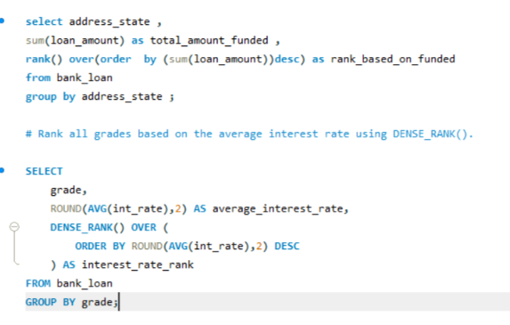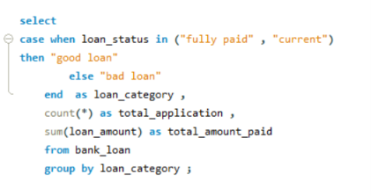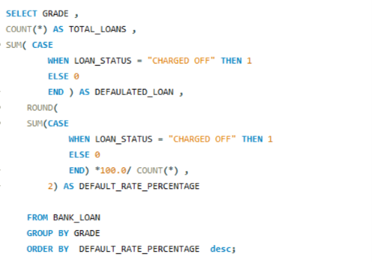

Power BI Dashboard
- Microsoft Power BI was used to transform the analyzed banking loan data into interactive dashboards that provide clear and meaningful business insights. The dashboards enable stakeholders to monitor key performance indicators (KPIs), analyze loan performance, understand customer behavior, and evaluate geographical trends through an intuitive visual interface.
- The dashboard was designed with a focus on simplicity, interactivity, and business usability. Users can filter data dynamically, navigate between different pages, and explore insights from multiple perspectives.

- Data Import and Modeling
- After completing data cleaning in Python and business analysis in MySQL, the cleaned dataset was imported into Power BI.
- The following tasks were completed during data modeling:
- Imported the cleaned banking loan dataset.
- Verified data types for all columns.
- Created relationships between tables (where applicable).
- Built a Calendar Table for time-based analysis.
- Established relationships between the Calendar Table and the loan dataset.
- Validated the data model to ensure accurate reporting.
- A well-structured data model improves report performance and ensures correct calculations.

- 9.3 DAX Measures
- Data Analysis Expressions (DAX) were used to create dynamic measures that automatically update based on user selections.
- Some of the key measures created include:
- Total Loan Applications
- Total Funded Amount
- Total Amount Received
- Average Interest Rate
- Average Annual Income
- Average Debt-to-Income Ratio (DTI)
- Month-to-Date (MTD) KPIs
- Month-over-Month (MoM) Comparisons
- These measures enable interactive and real-time business analysis.

- 9.4 Dashboard Design
- The dashboard was designed using modern business intelligence principles to improve readability and user experience.
- The design includes:
- KPI Cards
- Column Charts
- Bar Charts
- Donut Charts
- Line Charts
- Filled Map Visualization
- Slicers
- Page Navigation Buttons
- Interactive Filters
- Consistent Banking Theme
- The layout allows users to quickly identify important trends and performance metrics.

- 9.5 Interactive Features
- To improve usability, several interactive features were implemented:
- Page Navigation Buttons
- Dynamic Slicers
- Cross-filtering between visuals
- Drill-down capabilities
- Hover tooltips
- Responsive KPI cards
- Interactive filtering by year, loan status, and grade
- These features allow users to explore the data without modifying the underlying dataset.

- 9.6 Dashboard Pages
- The final Power BI solution consists of four interactive dashboard pages:
- Dashboard Page | - Purpose
- Executive Overview | - Overall banking performance and KPIs
- Loan Performance Analysis | - Loan trends, funding, repayments, and loan status
- Customer Analysis | - Customer demographics, loan purpose, and home ownership
- Geographic Analysis | - State-wise loan distribution and regional performance
- Each dashboard focuses on a specific business area while maintaining a consistent design and navigation experience.

- 9.7 Benefits of the Dashboard
- The Power BI dashboard provides several business advantages:
- Real-time KPI monitoring.
- Improved decision-making through visual insights.
- Faster analysis of loan performance.
- Better understanding of customer behavior.
- Easy identification of regional lending trends.
- Interactive reporting with user-friendly filters.
- Professional presentation of business metrics.

- 9.8 Dashboard Development Workflow
- Insert the following workflow diagram:
- Cleaned Dataset
- │
- ▼
- Import into Power BI
- │
- ▼
- Data Modeling
- │
- ▼
- Create DAX Measures
- │
- ▼
- Build Visualizations
- │
- ▼
- Add Slicers & Navigation
- │
- ▼
- Interactive Dashboard
- │
- ▼
- Business Insights

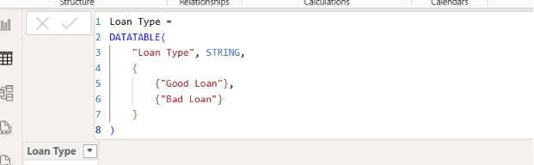
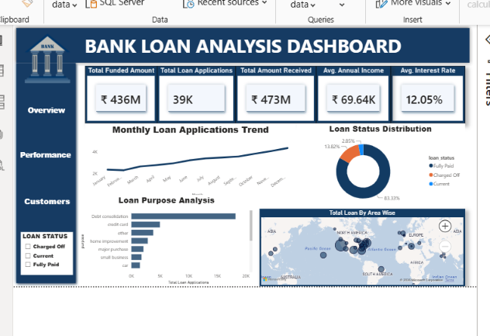
- Loan Performance Dashboard
- 11.1 Introduction
- The Loan Performance Dashboard focuses on evaluating the overall performance of the bank's loan portfolio. It provides detailed insights into loan funding, repayment trends, loan status, and customer repayment behavior. This dashboard helps management assess the effectiveness of lending operations and identify potential risks within the portfolio.
- By presenting key financial metrics and performance indicators, the dashboard enables stakeholders to monitor lending activities and make informed business decisions.

- 11.2 Objective
- The primary objectives of the Loan Performance Dashboard are to:
- Analyze the bank's loan funding performance.
- Monitor repayment trends.
- Evaluate loan status distribution.
- Identify repayment risks.
- Compare funded amounts and received payments.
- Support decisions related to credit and risk management.

- 11.3 Key Performance Indicators (KPIs)
- The dashboard includes the following KPIs:
- Total Funded Amount
- Total Amount Received
- Total Loan Applications
- Average Interest Rate
- Average Debt-to-Income Ratio (DTI)
- Percentage of Fully Paid Loans
- Percentage of Charged-Off Loans
- These KPIs provide a clear overview of loan portfolio performance and repayment outcomes.
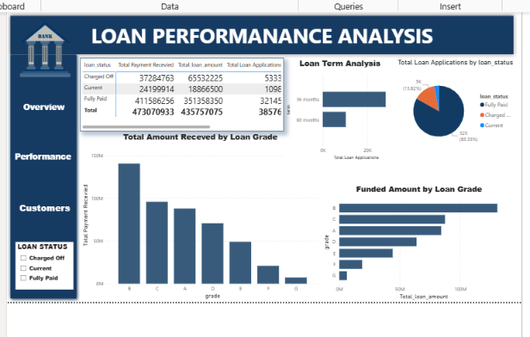
Key Insights
The Loan Performance Dashboard provides several valuable insights:
- Total funded amount reflects the overall lending activity during the analysis period.
- Total amount received indicates the effectiveness of loan repayment.
- Loan status analysis highlights the proportion of Fully Paid, Current, and Charged-Off loans.
- Trends in funding and repayments help identify seasonal or monthly variations.
- Comparison across loan grades and purposes supports evaluation of lending performance.

- Customer Analysis Dashboard
- 12.1 Introduction
- The Customer Analysis Dashboard focuses on understanding customer demographics, borrowing behavior, and loan preferences. It provides insights into how different customer segments contribute to the bank's loan portfolio and helps identify patterns that support customer-centric lending strategies.
- By analyzing customer characteristics such as home ownership, annual income, loan purpose, loan grade, and repayment behavior, the dashboard enables the bank to better understand its customer base and improve decision-making.

- 12.2 Objective
- The primary objectives of the Customer Analysis Dashboard are to:
- Analyze customer borrowing behavior.
- Identify major customer segments.
- Evaluate loan purposes and customer preferences.
- Study the relationship between customer income and loan amounts.
- Understand home ownership patterns.
- Support customer-focused business strategies.

- 12.3 Key Performance Indicators (KPIs)
- The dashboard highlights the following KPIs:
- Total Loan Applications
- Average Annual Income
- Average Loan Amount
- Average Interest Rate
- Loan Applications by Home Ownership
- Loan Applications by Purpose
- Loan Applications by Loan Grade
- These KPIs help evaluate customer profiles and borrowing patterns.

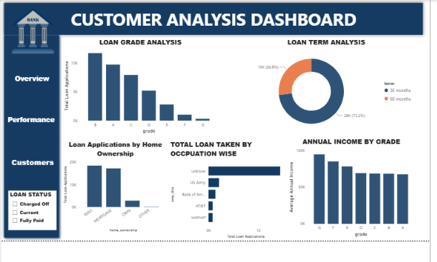

- Geographic Analysis Dashboard
- 13.1 Introduction
- The Geographic Analysis Dashboard provides insights into the regional distribution of loan applications, funded amounts, and customer activity across different states. It helps the bank understand geographical lending patterns, identify high-performing regions, and recognize areas that may require additional business focus.
- By visualizing location-based data, the dashboard supports strategic planning, regional performance monitoring, and resource allocation.

- 13.2 Objective
- The primary objectives of the Geographic Analysis Dashboard are to:
- Analyze state-wise loan applications.
- Compare funded amounts across different regions.
- Identify high-performing and low-performing states.
- Understand regional lending patterns.
- Support strategic business expansion and regional planning.

- 13.3 Key Performance Indicators (KPIs)
- The dashboard includes the following KPIs:
- Total Loan Applications by State
- Total Funded Amount by State
- Total Payment Received by State
- Average Loan Amount by State
- Average Interest Rate by State
- Loan Status Distribution by Region
- These KPIs provide a comprehensive overview of regional lending performance.

Visualizations Used
Visualization | Purpose
Filled Map | Display state-wise loan distribution
Bar Chart | Compare funded amounts across states
Column Chart | Compare total loan applications by state
KPI Cards | Display regional performance metrics
Donut Chart | Analyze loan status by region
Slicers | Filter data by year, loan status, and grade
- Key Insights
- The Geographic Analysis Dashboard provides several important insights:
- Loan applications are concentrated in specific states.
- Certain regions contribute a higher share of the total funded amount.
- Regional repayment performance varies across states.
- Geographic comparisons help identify high-growth and underperforming markets.
- Interactive filtering allows users to compare regional performance across different time periods and loan categories.
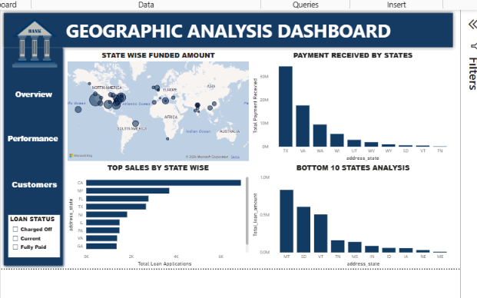

Business Insights
Introduction The analysis of the banking loan dataset using Python, SQL, and Power BI generated several valuable business insights. These insights help management understand lending performance, customer behavior, repayment trends, and regional distribution. The findings can be used to improve strategic planning, optimize lending policies, and support data-driven decision-making.

- Major Business Insights
- 1. Loan Portfolio Performance
- The analysis shows that the bank has processed a substantial number of loan applications, resulting in a significant total funded amount and payment received. This indicates active lending operations and a well-established customer base.

- 2. Loan Status Distribution
- The loan portfolio consists of different loan statuses, including Fully Paid, Current, and Charged-Off loans. Monitoring the proportion of each category helps evaluate repayment performance and identify areas requiring closer risk management.

- 3. Customer Borrowing Behavior
- Customer analysis revealed that borrowing patterns vary across different home ownership categories, income levels, and loan purposes. Understanding these patterns enables the bank to design customer-focused lending strategies and improve service offerings.

- 4. Loan Purpose Trends
- Certain loan purposes contribute a larger share of total loan applications than others. This information helps identify the products and services that customers value most and supports the development of targeted financial products.

- 5. Loan Grade Analysis
- Loan grades show differences in funding amounts, repayment performance, and lending risk. Analyzing loan grades allows the bank to assess credit quality and improve credit approval processes.

- 6. Regional Lending Performance
- Geographic analysis highlights that loan applications and funded amounts are concentrated in specific states. Regional performance comparisons help identify high-growth markets and areas that may require additional business attention.

- 7. Interest Rate Analysis
- The analysis indicates variations in interest rates across different customer segments and loan categories. Understanding these trends supports more effective pricing strategies and improved risk assessment.

- 8. Income and Borrowing Relationship
- Customer income levels influence borrowing capacity and loan amounts. This relationship provides useful information for evaluating customer eligibility and designing suitable lending products.

- 9. Dashboard-Based Decision Support
- The interactive Power BI dashboards enable users to monitor KPIs, filter data dynamically, and explore business performance from multiple perspectives. This improves reporting efficiency and supports faster decision-making.

- 14.3 Overall Business Impact
- The project demonstrates how modern data analytics tools can convert raw banking data into meaningful business intelligence. By combining Python, SQL, MySQL, and Power BI, the bank can monitor performance, identify opportunities, manage risks, and make informed strategic decisions.

Recommendations
- Introduction
- Based on the analysis of the banking loan dataset using Python, SQL, and Power BI, several recommendations can be made to improve lending performance, reduce financial risk, enhance customer satisfaction, and support business growth. These recommendations are derived from the insights obtained during data analysis and dashboard development.
- Recommendations
- 1. Strengthen Credit Risk Assessment
- The bank should continuously monitor loan grades, repayment history, and debt-to-income (DTI) ratios before approving loans. Improving credit assessment can reduce the number of high-risk loans and minimize future defaults.

- 2. Focus on High-Performing Customer Segments
- Customer segments with strong repayment performance should be targeted with personalized loan products and promotional campaigns. This can improve customer retention and increase lending opportunities.

- 3. Improve Monitoring of Charged-Off Loans
- Loans classified as Charged-Off should be analyzed regularly to identify common characteristics and underlying causes. Early detection of high-risk accounts can help reduce financial losses.

- 4. Develop Region-Specific Lending Strategies
- Regional analysis shows that lending performance varies across states. The bank should focus on expanding operations in high-performing regions while investigating challenges in lower-performing areas.

- 5. Optimize Interest Rate Policies
- Interest rates should be reviewed periodically to balance profitability and customer affordability. A risk-based pricing approach can help maintain competitiveness while protecting the bank from excessive lending risk.

- 6. Expand Customer-Centric Loan Products
- Understanding customer loan purposes and borrowing patterns can help the bank design products that better meet customer needs. Tailored financial products can improve customer satisfaction and increase loan demand.

- 7. Implement Real-Time Performance Monitoring
- Interactive Power BI dashboards should be used regularly by management to monitor KPIs, identify emerging trends, and support timely decision-making.

- 8. Encourage Data-Driven Decision-Making
- Business decisions should be based on analytical insights rather than intuition alone. Integrating dashboards into routine reporting can improve operational efficiency and strategic planning.

- 15.3 Expected Business Benefits
- Implementing these recommendations can provide several advantages:
- Improved loan portfolio quality.
- Better management of credit risk.
- Higher customer satisfaction and retention.
- More effective allocation of business resources.
- Faster identification of business opportunities.
- Enhanced operational efficiency.
- Stronger support for strategic decision-making.
- Increased use of analytics in business planning

Conclusion
- The Bank Loan Analysis Dashboard project successfully demonstrates the complete end-to-end data analytics lifecycle, transforming raw banking loan data into meaningful business insights using modern analytics tools and techniques.
- The project began with data understanding and preprocessing using Python, where missing values, duplicate records, and data quality issues were identified and resolved. Exploratory Data Analysis (EDA) was then performed to understand customer behavior, loan characteristics, and lending patterns.
- The cleaned dataset was imported into MySQL, where SQL queries were used to calculate business KPIs, analyze customer segments, evaluate loan performance, and identify lending risks. Advanced SQL concepts such as aggregate functions, CASE statements, Common Table Expressions (CTEs), and window functions were applied to solve real-world business problems.
- Finally, the analyzed data was imported into Microsoft Power BI, where an interactive dashboard consisting of four business-focused pages was developed. The dashboard provides stakeholders with a comprehensive view of loan performance, customer analysis, and regional lending trends through interactive visualizations and dynamic filtering.
- Project Achievements
- The following objectives were successfully achieved during the project:
- Collected and understood the banking loan dataset.
- Cleaned and prepared the data using Python.
- Performed Exploratory Data Analysis (EDA).
- Stored the cleaned dataset in MySQL.
- Developed SQL queries to answer business questions.
- Created dynamic KPIs using DAX in Power BI.
- Built four interactive dashboard pages.
- Generated actionable business insights.
- Developed practical business recommendations.
- Documented the complete project in a professional report.
- Skills Demonstrated
- This project demonstrates practical knowledge of the following technical and analytical skills:
- Programming & Data Processing
- Python
- Pandas
- NumPy
- Database Management
- MySQL
- SQL Queries
- Aggregate Functions
- CASE Statements
- CTEs
- Window Functions
- Business Intelligence
- Microsoft Power BI
- Data Modeling
- DAX Measures
- Interactive Dashboards
- Data Visualization
- Analytical Skills
- Data Cleaning
- Exploratory Data Analysis (EDA)
- KPI Development
- Customer Segmentation
- Risk Analysis
- Business Insight Generation
- Skills Demonstrated
- This project demonstrates practical knowledge of the following technical and analytical skills:
- Programming & Data Processing
- Python
- Pandas
- NumPy
- Database Management
- MySQL
- SQL Queries
- Aggregate Functions
- CASE Statements
- CTEs
- Window Functions
- Business Intelligence
- Microsoft Power BI
- Data Modeling
- DAX Measures
- Interactive Dashboards
- Data Visualization
- Analytical Skills
- Data Cleaning
- Exploratory Data Analysis (EDA)
- KPI Development
- Customer Segmentation
- Risk Analysis
- Business Insight Generation

Future Scope
- Although the current Bank Loan Analysis Dashboard provides comprehensive insights into loan performance and customer behavior, there are several opportunities to further enhance the project by incorporating advanced analytics, automation, and predictive capabilities.
- Future improvements can help financial institutions make even more accurate, efficient, and proactive business decisions.
- Potential Enhancements
- 1. Predictive Analytics
- Machine Learning models can be developed to predict:
- Loan default probability
- Customer repayment behavior
- Future loan demand
- High-risk customer segments
- These predictions can support better lending decisions and reduce financial risk.

- 2. Credit Risk Prediction
- Advanced classification algorithms can be used to identify customers who are more likely to default on their loans.
- Examples include:
- Logistic Regression
- Decision Tree
- Random Forest
- XGBoost
- This would improve credit risk assessment and loan approval processes.

- 3. Real-Time Dashboard Integration
- The dashboard can be connected to live databases using automated data refresh, enabling real-time monitoring of loan applications, repayments, and portfolio performance.

- 4. Cloud Deployment
- The solution can be migrated to cloud platforms such as:
- Microsoft Azure
- Amazon Web Services (AWS)
- Google Cloud Platform (GCP)
- Cloud deployment would improve scalability, accessibility, and collaboration.

- 5. Automated ETL Pipelines
- Instead of manually importing data, automated ETL pipelines can be created using tools such as:
- Azure Data Factory
- Apache Airflow
- Fivetran
- Talend
- This would ensure regular data updates and reduce manual effort.

- 6. AI-Powered Business Insights
- Artificial Intelligence can be integrated to automatically generate:
- Executive summaries
- Business recommendations
- Risk alerts
- Performance reports
- This would improve reporting efficiency and support faster decision-making.

- 7. Mobile Dashboard Access
- The Power BI dashboard can be optimized for mobile devices, allowing managers and executives to monitor KPIs and business performance from anywhere.

- 8. Integration with Banking Systems
- The dashboard can be integrated with core banking software and CRM systems to provide a unified view of customer information, loan portfolios, and operational performance.

- 17.3 Learning Outcomes
- This project has provided valuable practical experience in:
- End-to-end data analytics
- Data cleaning and preprocessing
- SQL-based business analysis
- Dashboard development
- Business intelligence reporting
- Data visualization
- Business problem-solving
- Professional documentation
- These skills form a strong foundation for working on larger analytics projects in industries such as banking, finance, healthcare, retail, and e-commerce.

- 17.4 Final Remarks
- The Bank Loan Analysis Dashboard serves as a practical example of how modern data analytics tools can transform raw data into actionable business intelligence. Future enhancements involving Machine Learning, Artificial Intelligence, cloud technologies, and automation can further improve the solution, making it more scalable, intelligent, and valuable for real-world business applications.

